**Kubernetes Objects**

* Everything in k8s is an object.
* Every object has a spec and status
* spec: specification (what we have asked)
* status: (what was created)

**Kubernetes API-Resources**

* The resources exposed by api-server  
  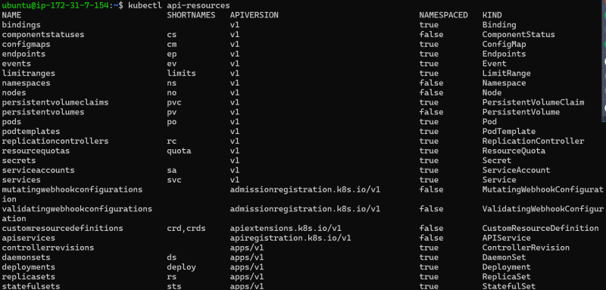

**K8s Workloads**

* <https://kubernetes.io/docs/concepts/overview/working-with-objects/kubernetes-objects/> for the official docs  
  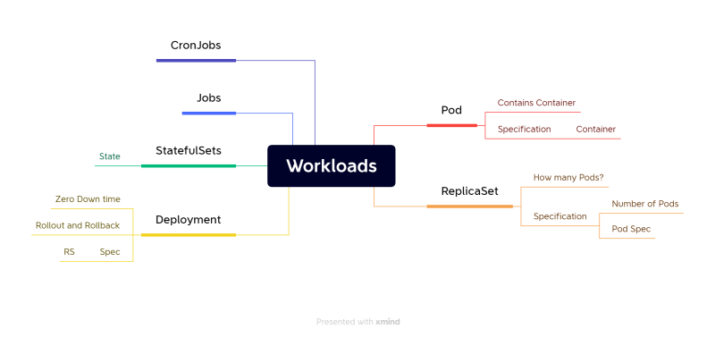
* Pods:
* Primitive of k8s.
* The smallest unit of creation is Pod.
* Pod has container(s)
* Every Pod gets an IP address

**How to Create Resources in K8s**

* We would be creating k8s manifests i.e yaml files
* For this we need to understand
  + yaml
  + api versioning
  + Spec and Status

**API Versioning**

* <https://kubernetes.io/docs/reference/using-api/> for docs
* APIs are grouped as apigroups:
  + core
  + batch
  + networking.k8s.io
* Api version: This is written as <groupname>/<Version>, if the group name is core <version>
* In this groups we have kind of api-resources

**Defining Resources in a manifest file**

* To define a resource in a manifest file we create a yaml file with following structure

apiVersion:

kind:

metadata:

spec:

* Open the api reference <https://kubernetes.io/docs/reference/generated/kubernetes-api/v1.27/>

**Pods**

* Pod is atomic unit of creation in k8s cluster
* Pod contains container(s)  
  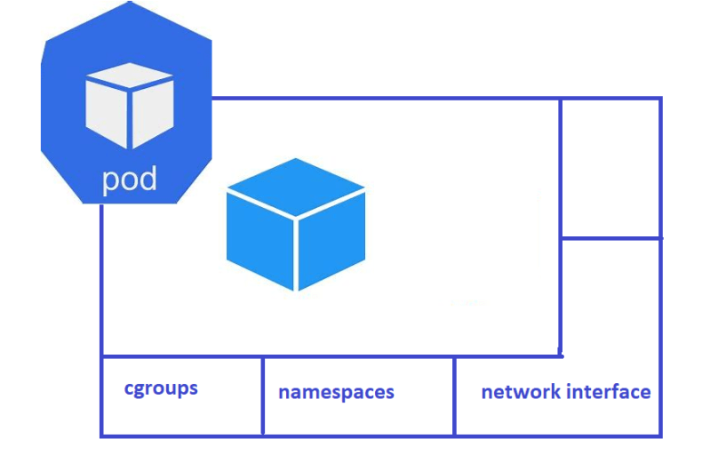
* Each Pod gets a unique ip address
* Pod can have multiple containers
* Scaling in k8s is increasing number of pods not containers  
  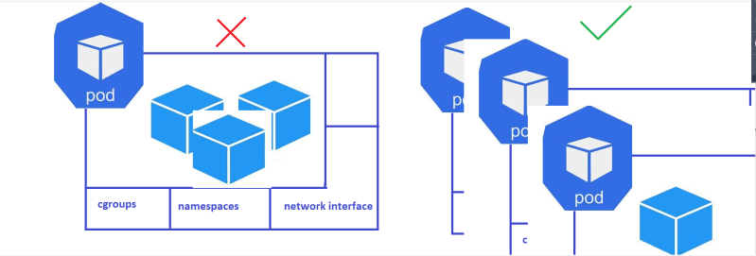
* Pod gets assigned to node
* <https://kubernetes.io/docs/concepts/workloads/pods/> for official docs
* <https://github.com/asquarezone/KubernetesZone/commit/fa4f7688095eafbbc273db30a2adfabc21d67471> for podspecs
* kubectl cheatsheet <https://kubernetes.io/docs/reference/kubectl/cheatsheet/>
* using kubectl to create pods  
  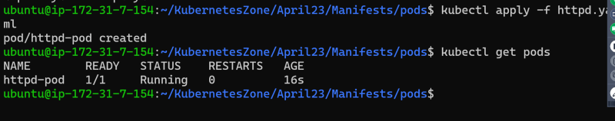
* commands

kubectl apply -f

kubectl get <api-resource>

kubectl describe <kind> <name>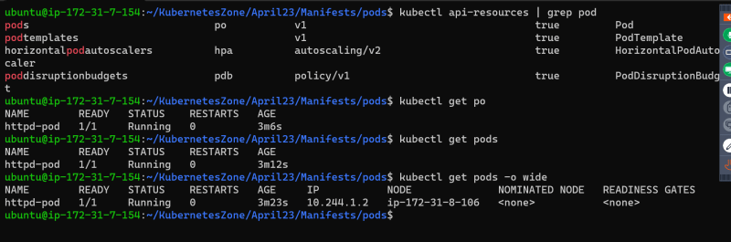  
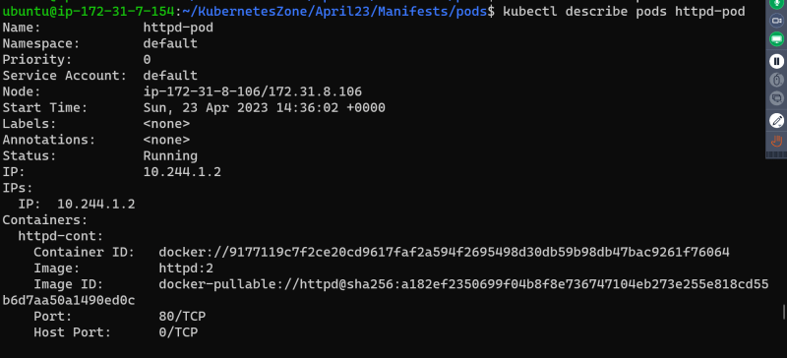  
* To view the complete manifest created by k8s

kubectl get <kind> <name> -o yaml

delete pods  
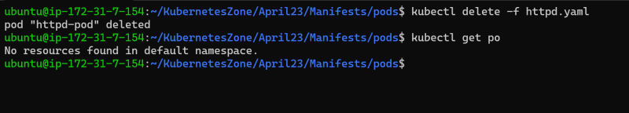

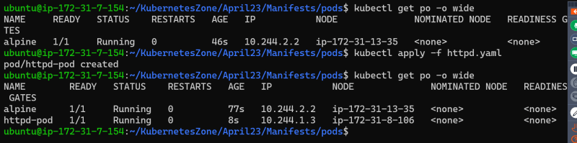

**Exercises>** Write a manifest file to create pod

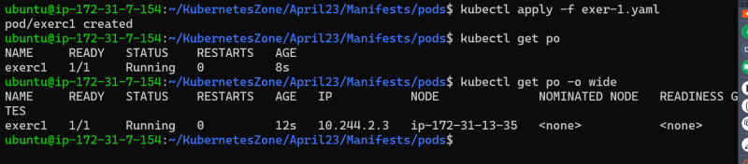

nginx and alpine with sleep 1d  
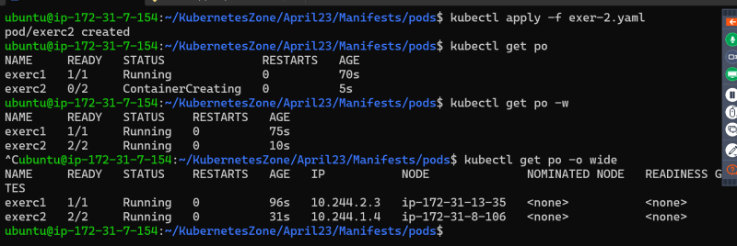

nginx ,alpine with sleep 1d and alpine with 10s  
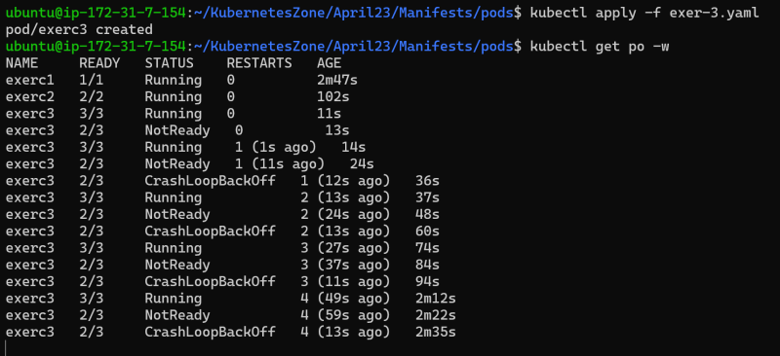

nginx and httpd with 80 port exposed  
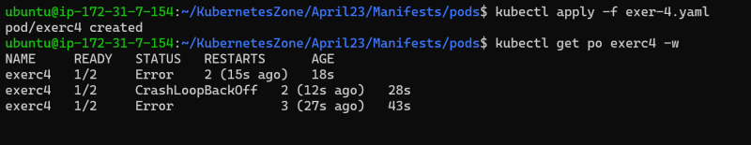

<https://github.com/asquarezone/KubernetesZone/commit/180512c9ad65135676bd76b18c8bec1f23665217> for the changeset with 4 yamls

